

Sri Lanka Institute of Information Technology

[**Enterprise Standards and Best Practices for IT Infrastructure**](http://courseweb.sliit.lk/course/view.php?id=137)

**LAB 01**

**Creating Windows AMI instance using AWS**

**IT 130 699 64**

**Subhani K.G.D.**

**Weekday IT**

**14th July 2016**

Creating Windows Instance using AWS account.

1. First user has to login to the AWS account using correct username and password.

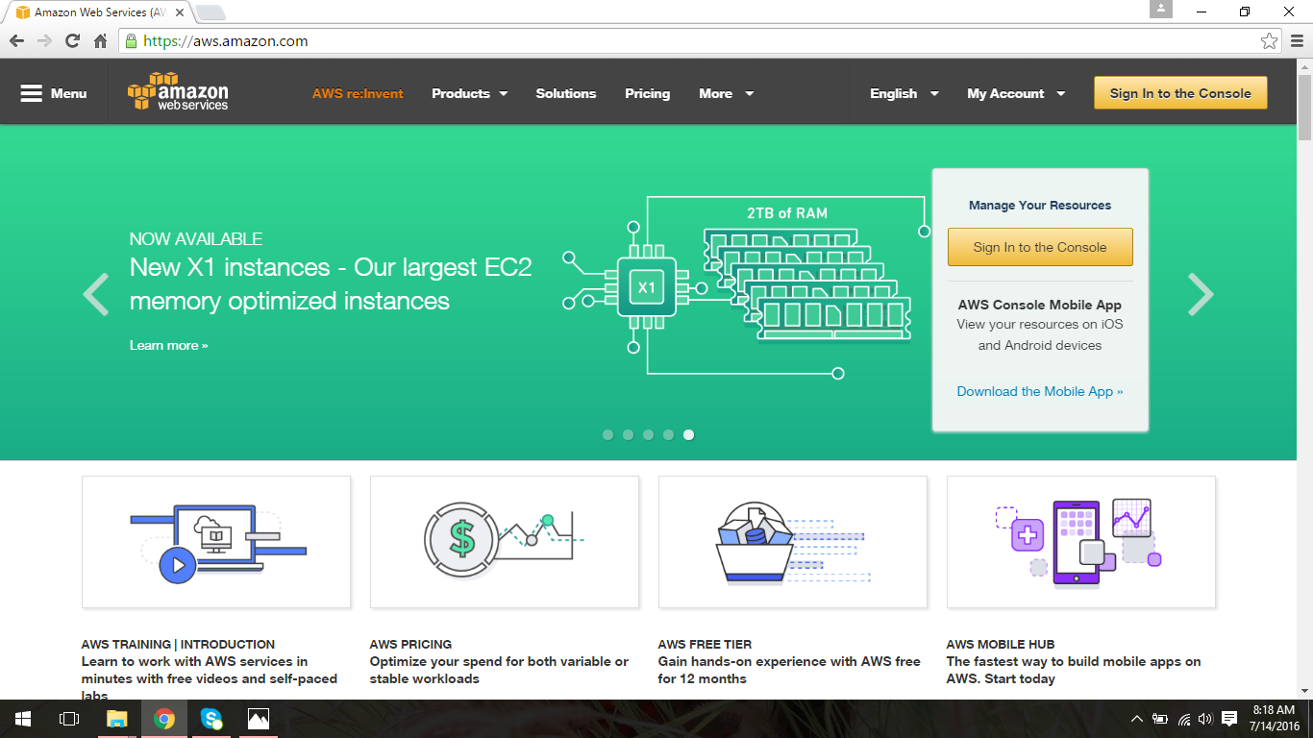

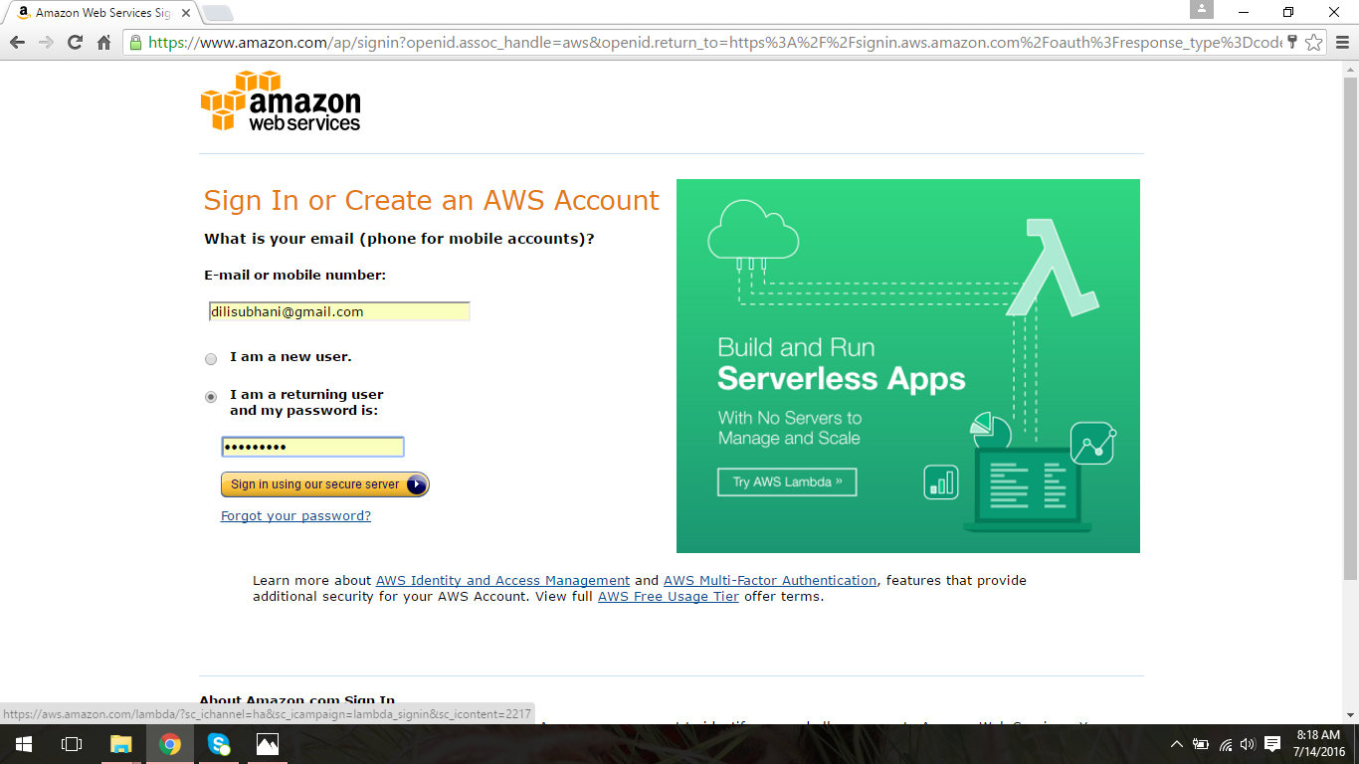

1. Then select EC2 tab to create a new instance.

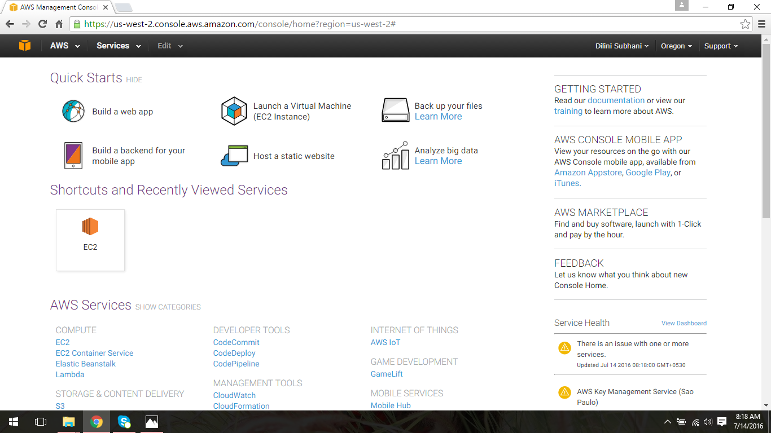

1. Then click “Launch Instance” button and from the list of AMI s appeared on the screen select “Microsoft Windows Server 2012 R2 Base” AMI to create windows instance.

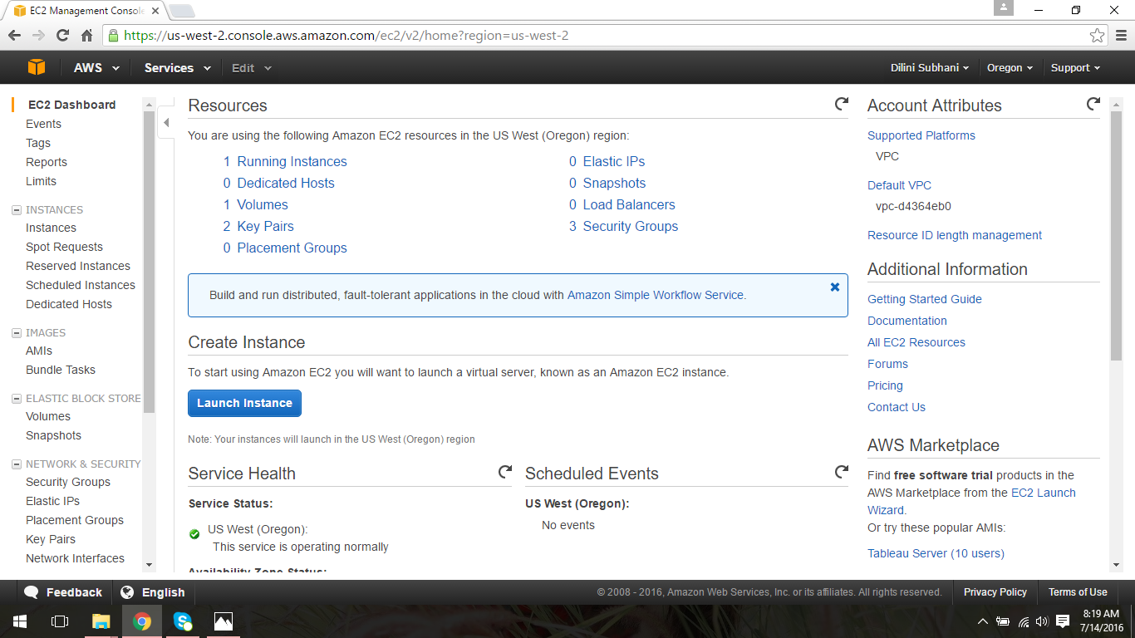

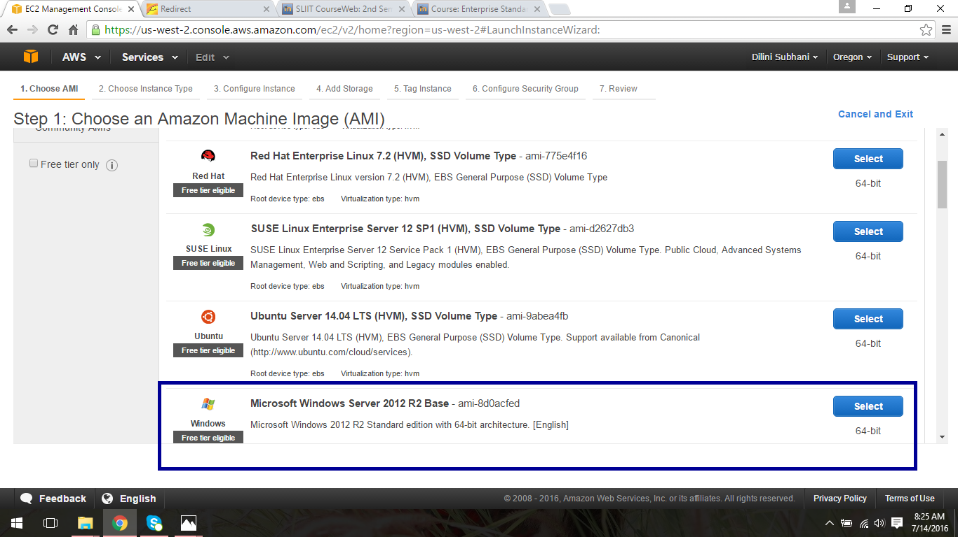

1. Select the default instance type given and click “Preview and Launch” button.

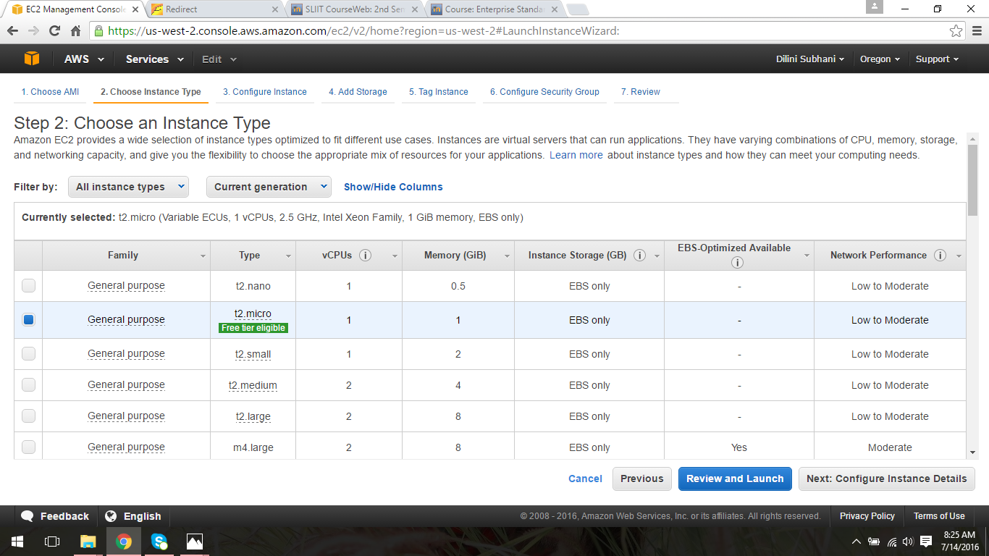

1. Then after creating the instance next step is reviewing the instance created. Click the “Launch” button to continue.

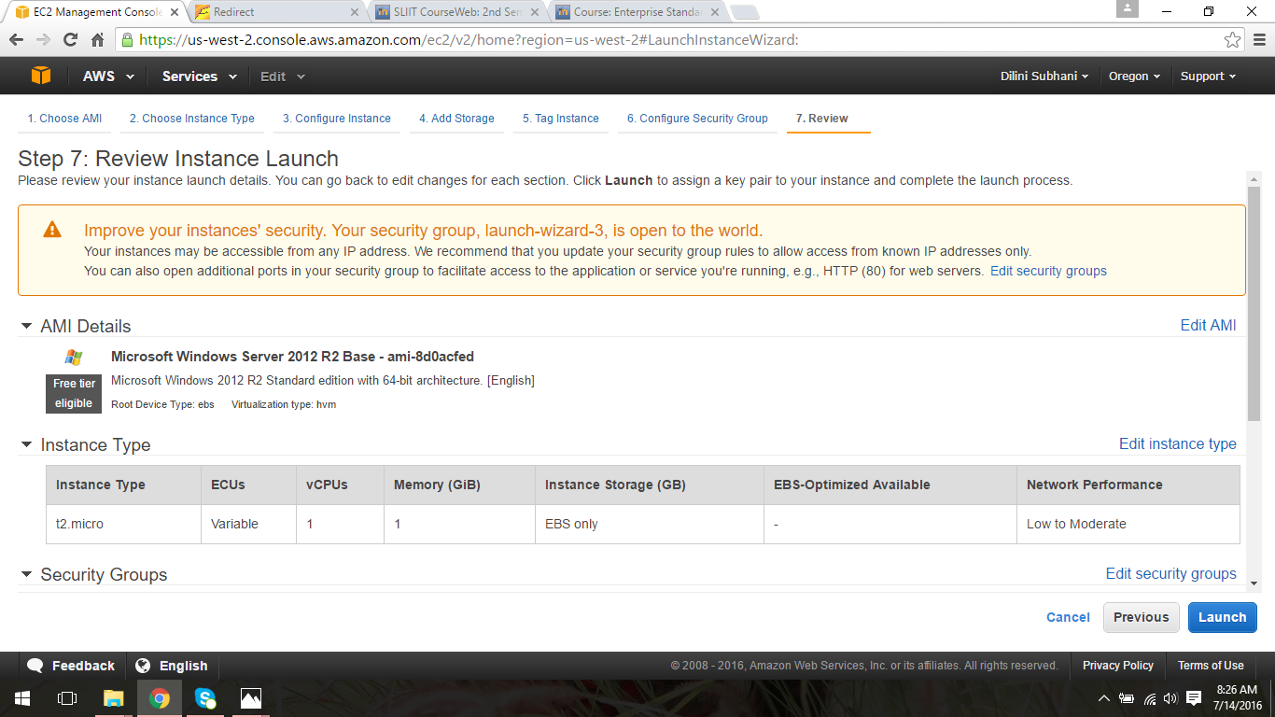

1. Next user has to create a new key pair to launch the newly created instance by providing a name to the key pair.

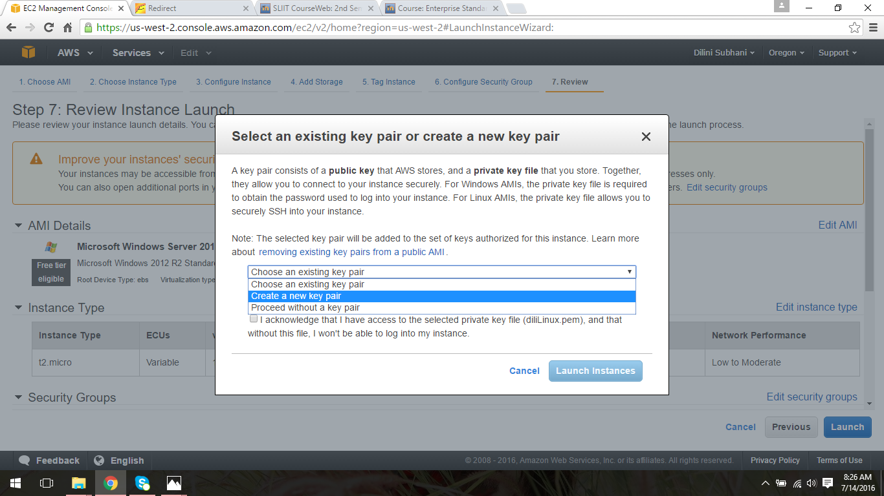

1. Next click “Download Key pair” button to download the key pair to your system and “dil_windows.pem” file will be downloaded.

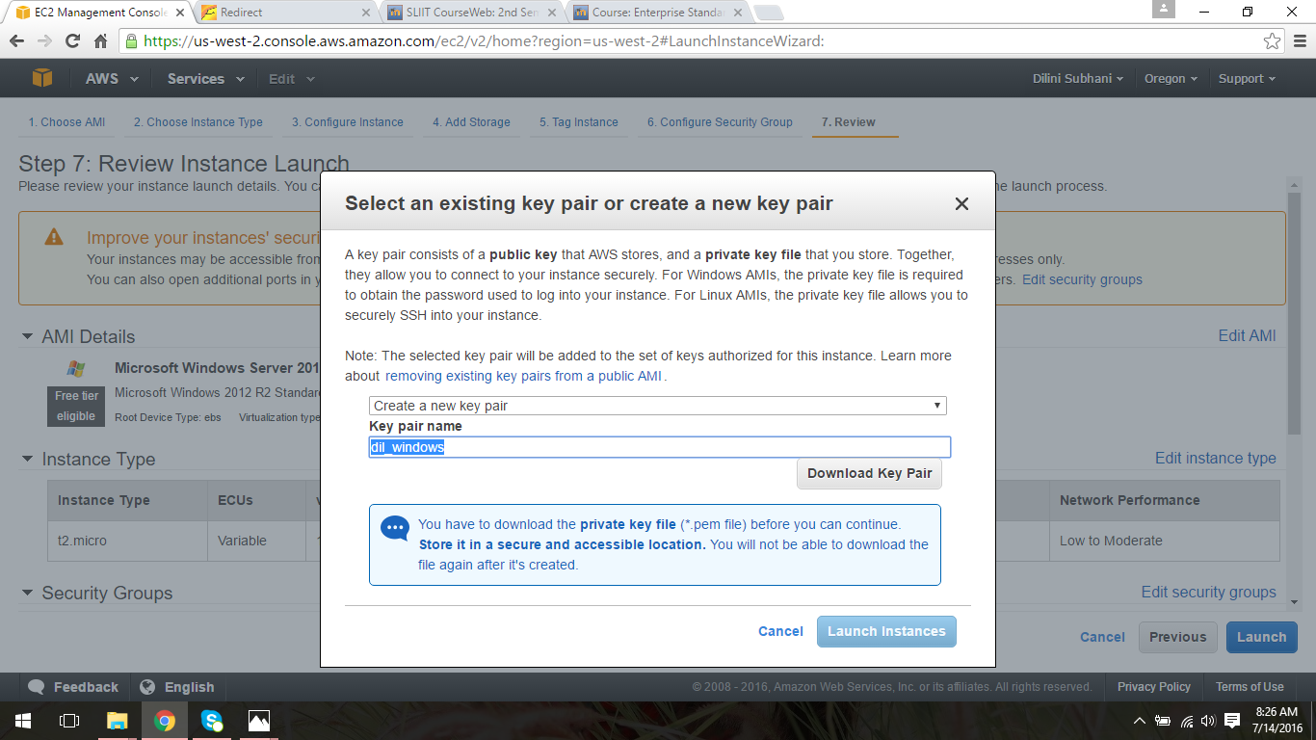

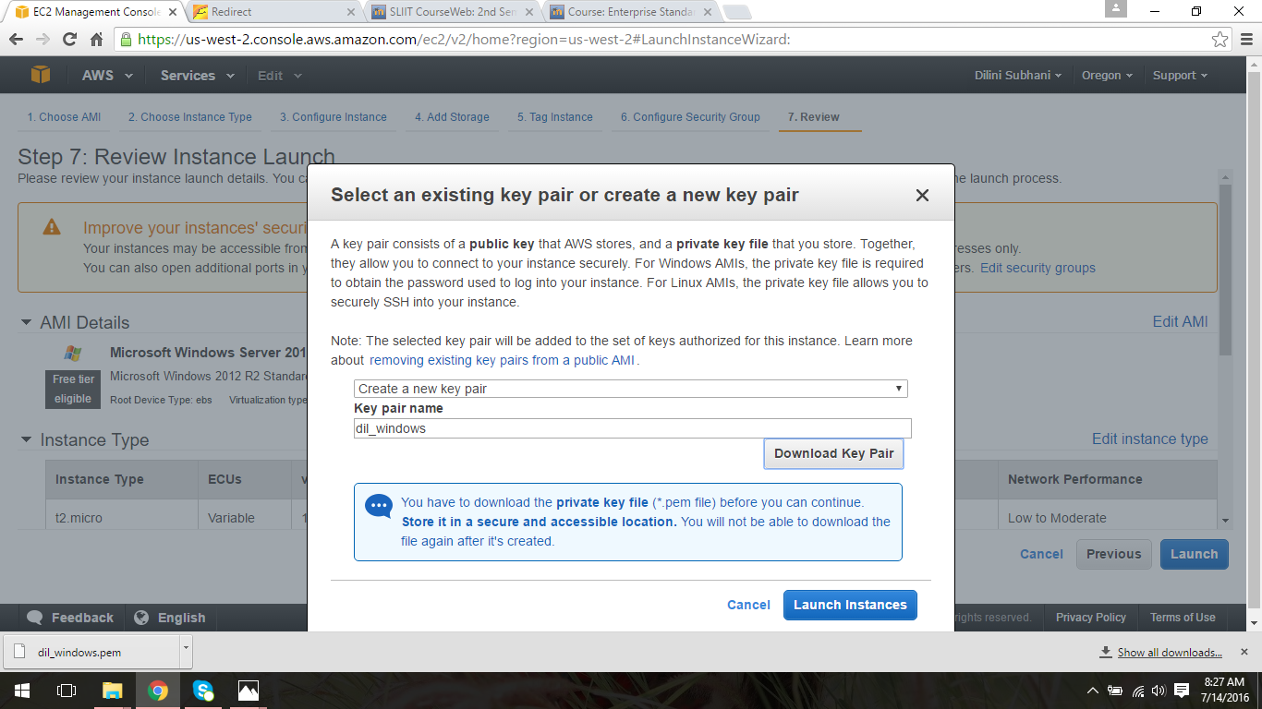

1. Then created instance will be launched as shown below and click the “View instance” button to view the instance you created.

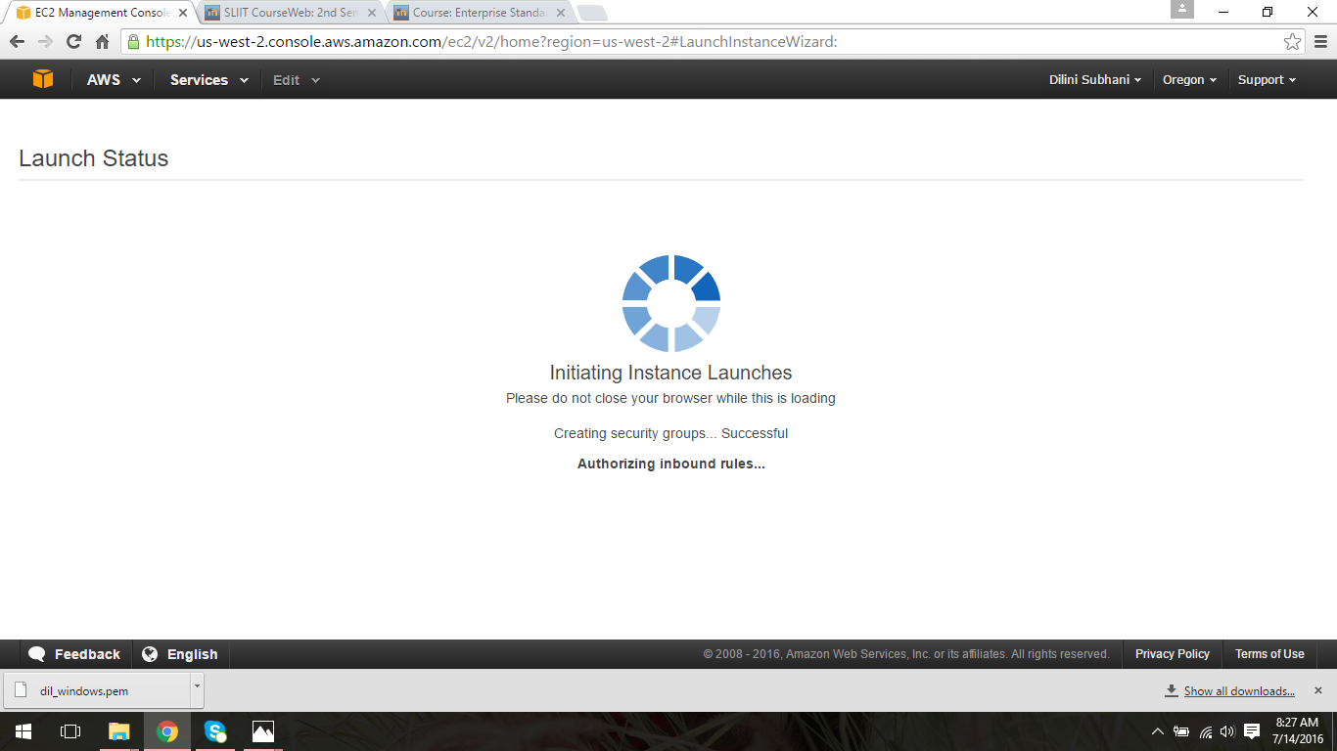

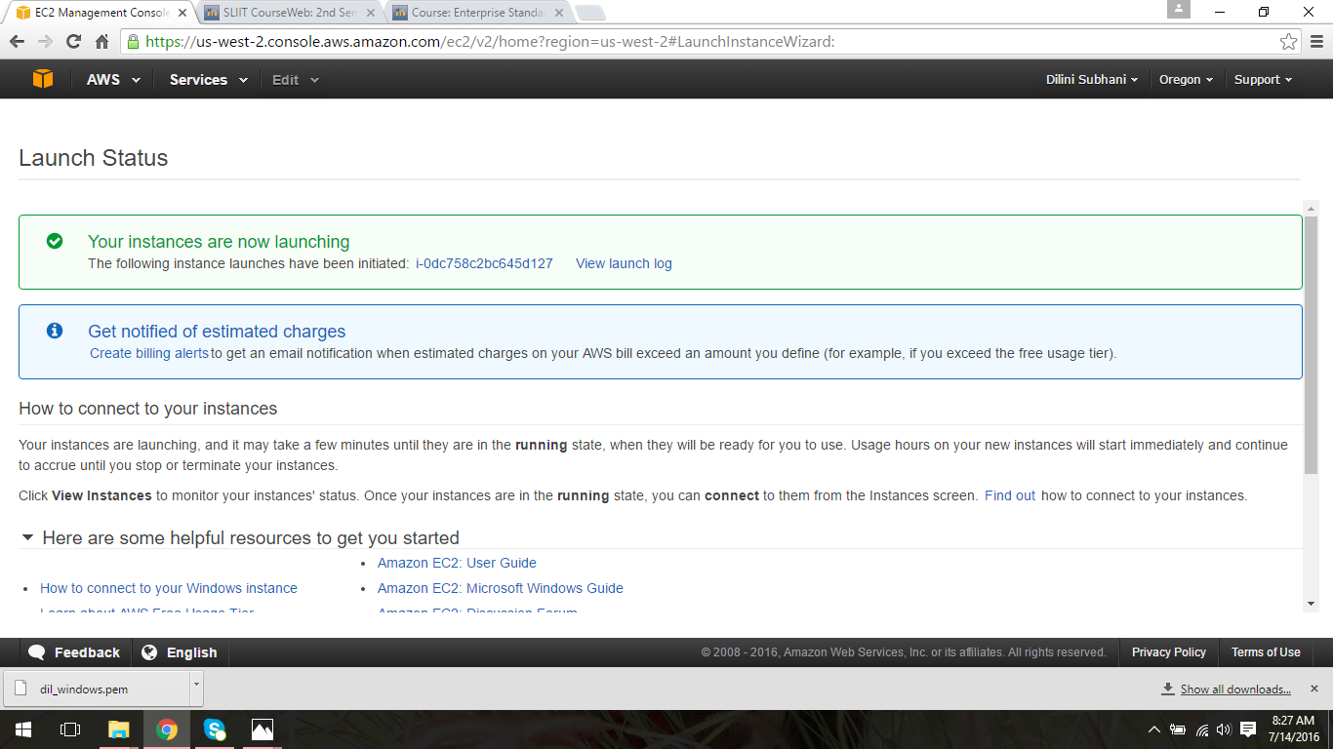

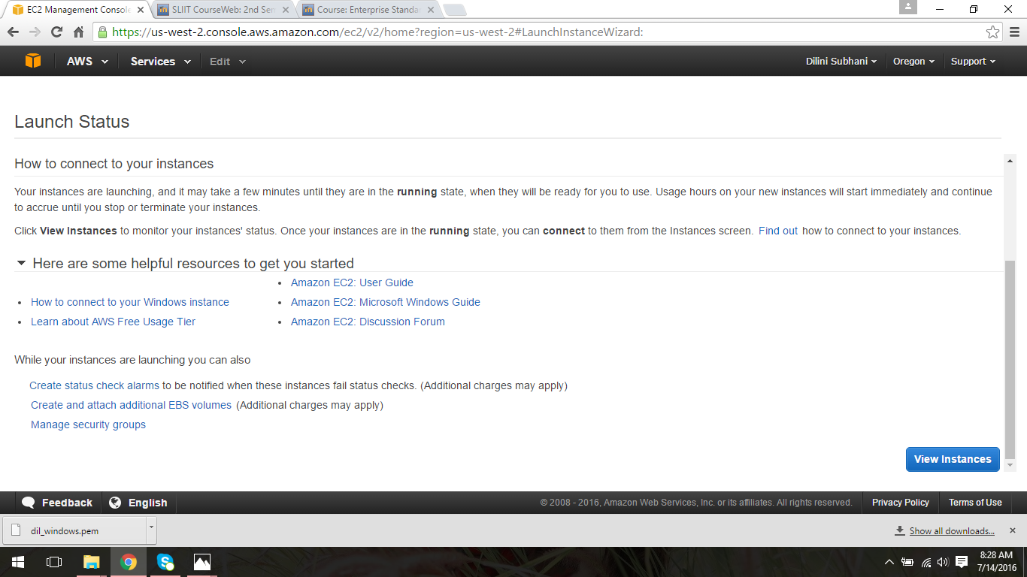

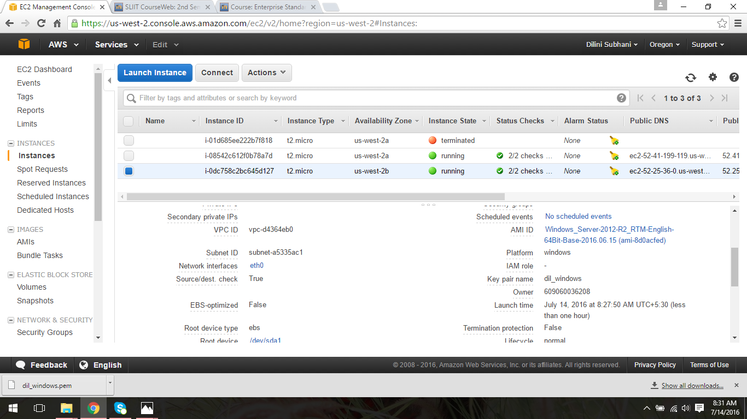

1. Then to connect to the instance click “Connect” button. To get connect to the instance first user should get a password.

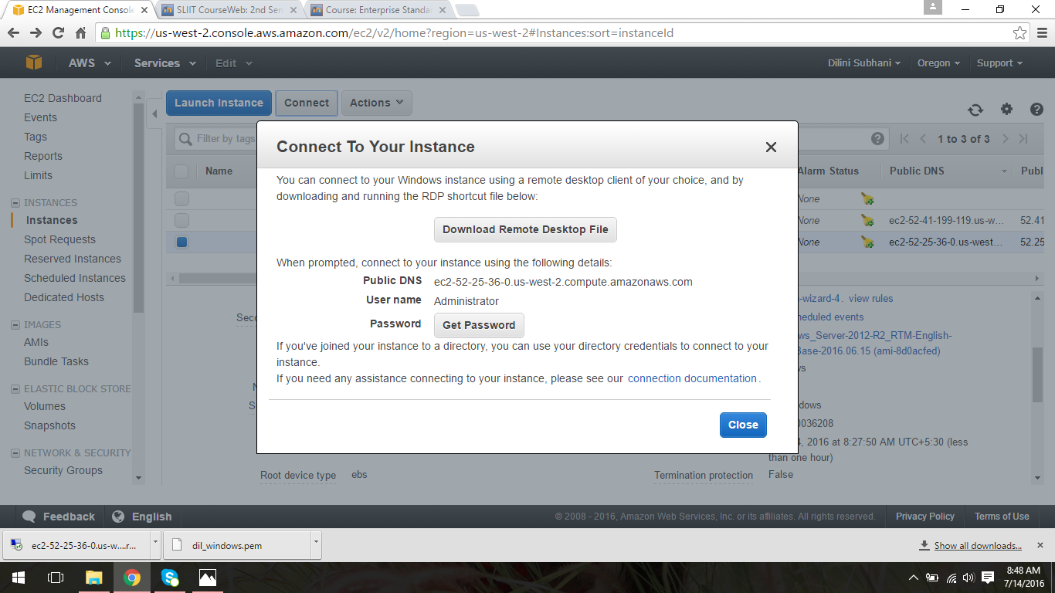

1. Next to get the password should provide the path of “dil_windows.pem” file and decrypt the password.

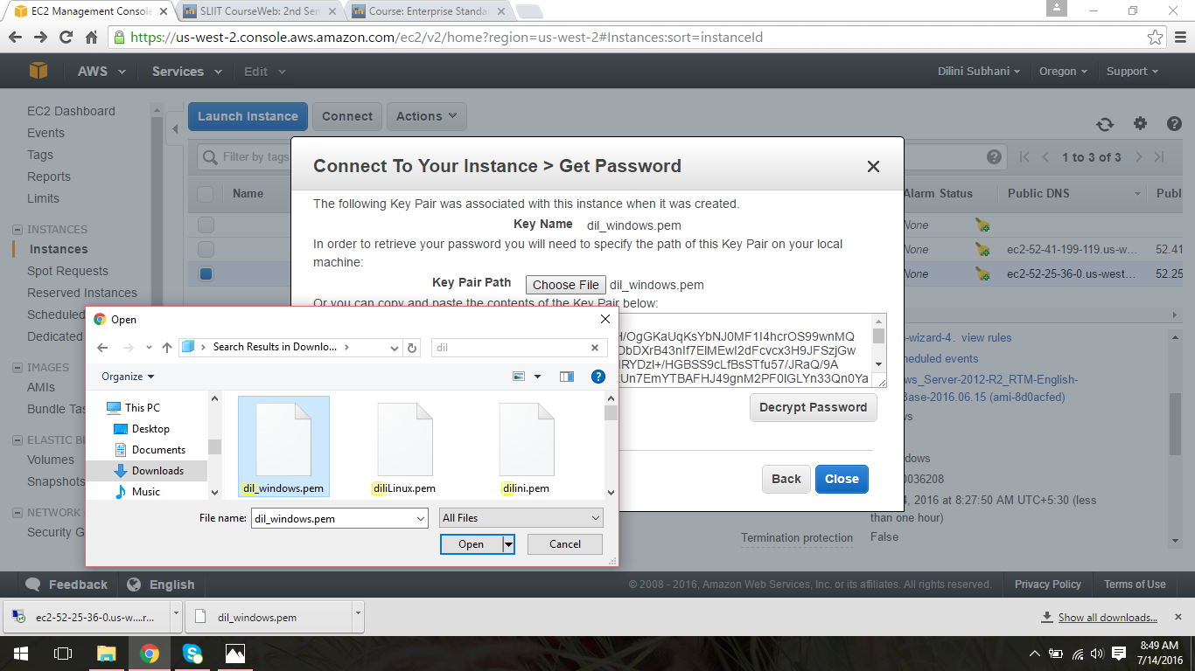

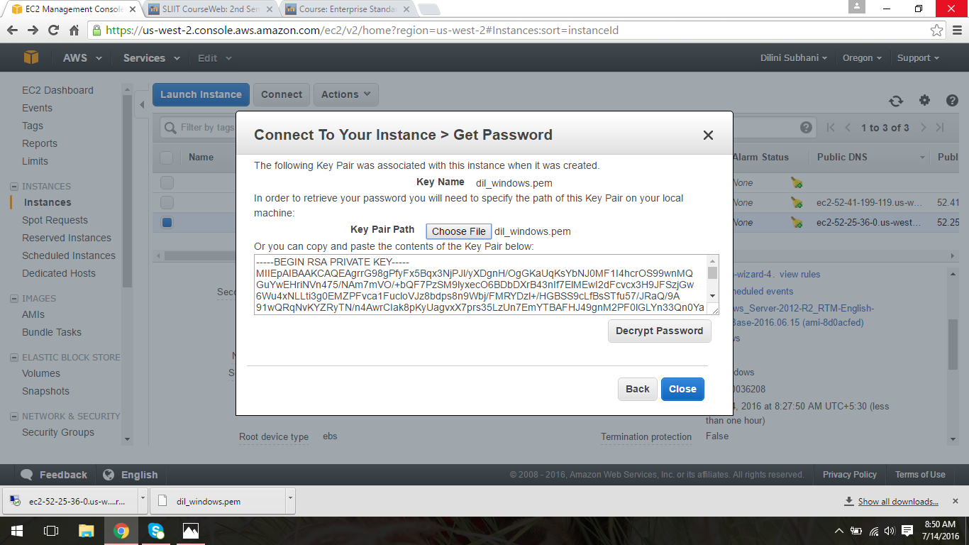

1. Then user can get the password to access the instance and click “Download Remote Desktop File” button to download the file.

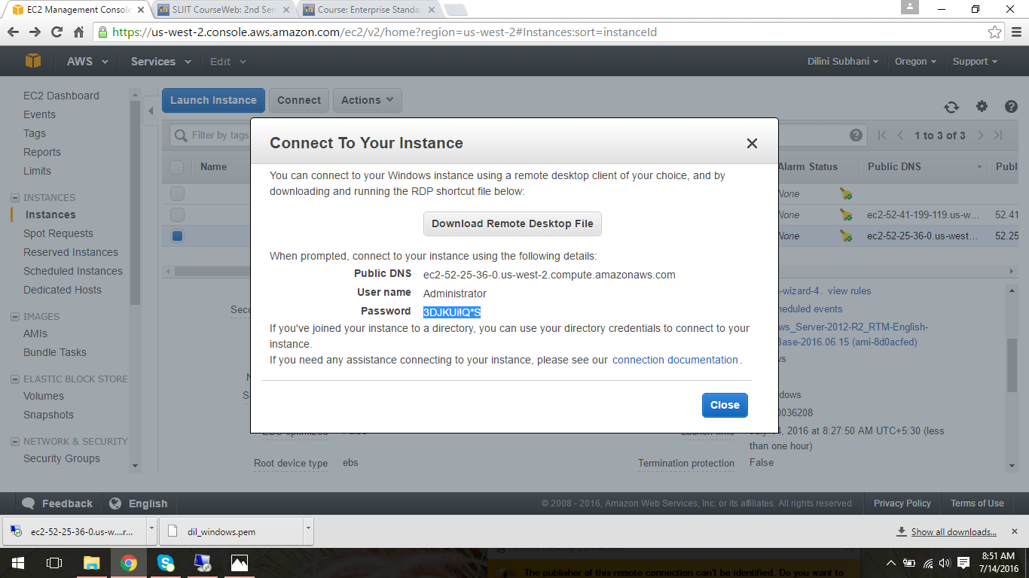

1. Then double click the downloaded file and user has to provide the password received from the previous step to connect to the instance.

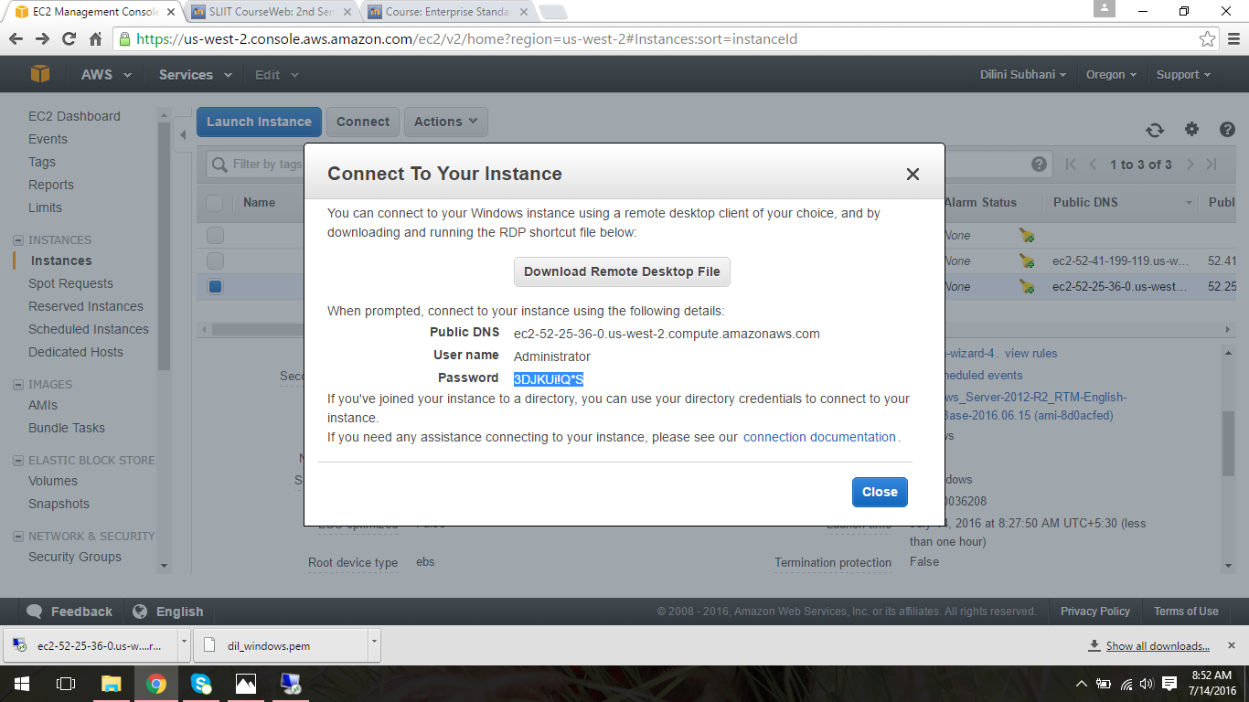

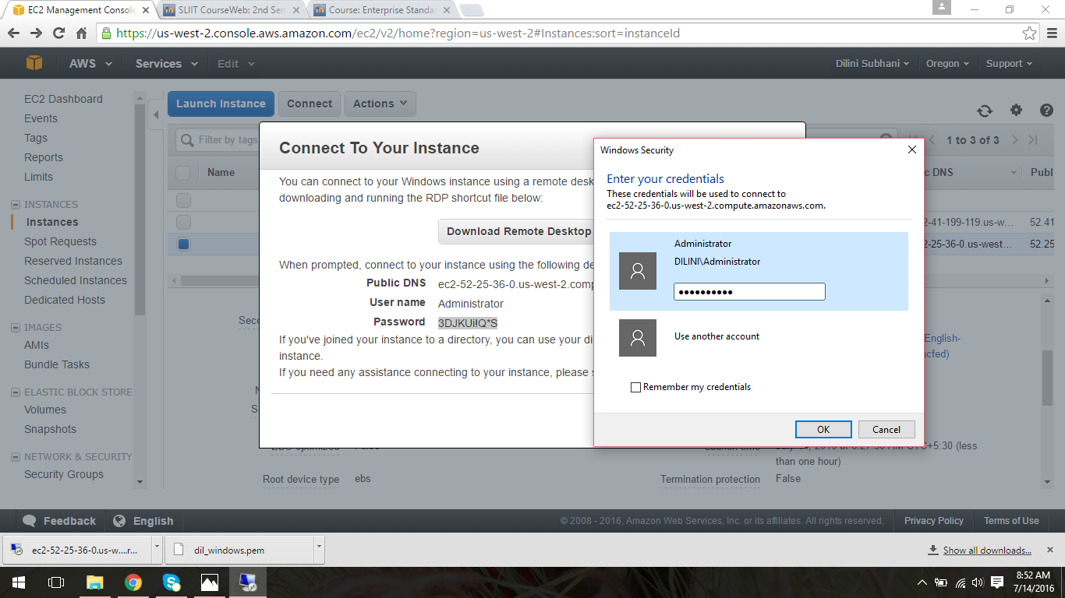

1. Click “Yes” to continue.

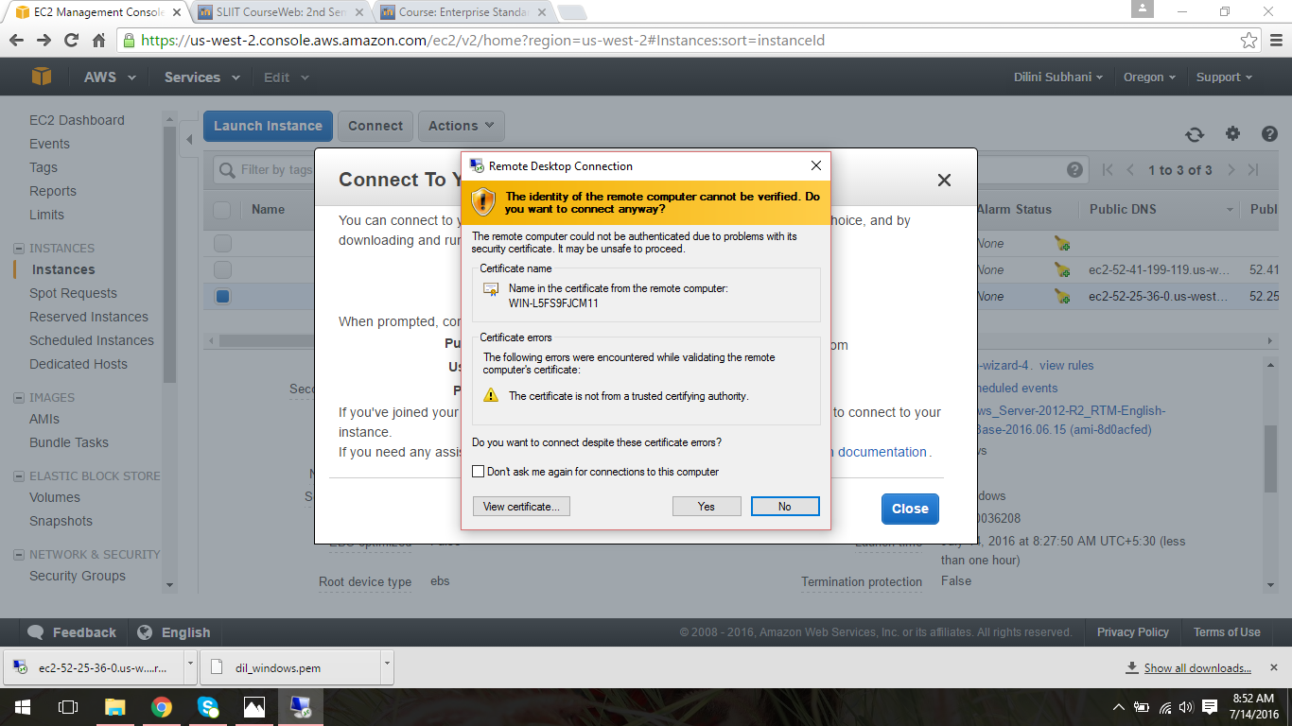

1. Then user can access to the created Windows instance AMI.

